VHA Point of Service (Kiosks) Phase II

User Guide

for

After Visit Summary (AVS)



Delivery Order VA118-11-D-1009

Task Order VA118-1009-0020

Department of Veterans Affairs

March 2015

Revision History

| Date | Revision | Description | Author |
| --- | --- | --- | --- |
| 3/19/2015 | 0.01 | Initial Draft | Caroline Lewis |
|  |  |  |  |

Table of Contents

1 Introduction 1

1.1 Purpose 1

1.2 Overview 2

1.3 Project References 3

1.3.1 Information 3

1.3.2 Coordination 3

1.3.3 Help Desk 3

1.4 Organization of the Manual 3

1.5 Acronyms and Abbreviations 4

2 System Summary 4

2.1 System Configuration 4

2.2 Data Flows 4

2.3 User Access Levels 4

2.4 Contingencies and Alternate Modes of Operation 4

3 Getting Started 5

3.1 AVS Workflow 5

3.2 Logging On 5

3.2.1 Launching the AVS 5

3.2.2 AVS Sections 8

3.2.2.1 Header 8

3.2.2.2 Visit Info, Diagnoses, Vitals, Immunizations 9

3.2.2.3 New Orders 10

3.2.2.4 Appointments 11

3.2.2.5 Instructions 12

3.2.2.6 Primary Care Team 12

3.2.2.7 Allergies and Local VA Meds 13

3.2.2.8 Non-VA Medications 13

3.2.2.9 Lab Results 14

3.2.2.10 Clinical Charts 16

3.2.2.11 Footer 17

3.2.2.12 Toggling Sections 18

3.2.3 AVS Functionality 18

3.2.3.1 Patient Instructions 18

3.2.3.2 Edit AVS 19

3.2.3.3 Font Size 21

3.2.3.4 Clinical Services Information 22

3.2.3.5 Krames-On-Demand 25

3.2.3.6 Printing 30

3.2.3.7 Stub Note and VistA Imaging 33

3.2.3.8 Admin Settings 35

3.3 Changing User ID and Password 39

3.4 Exit System 39

3.5 Special Instructions for Error Correction 39

3.6 Caveats and Exceptions 39

4 Project-Specific Scenario 40

5 Troubleshooting 46

List of Figures

Figure 1 – Launching the After Visit Summary from CPRS 6

Figure 2 – AVS Interface 7

Figure 3 – AVS Visit Selection 8

Figure 4 – AVS Header 9

Figure 5 – AVS Visit Information 10

Figure 6 – AVS New Orders 11

Figure 7 – AVS Appointments 12

Figure 8 – AVS Instructions 12

Figure 9 – AVS Patient’s Primary Care Team 13

Figure 10 – Allergies and Local VA Meds 13

Figure 11 – Non-VA Medications 14

Figure 12 – Lab Results 14

Figure 13 – Recent Lab Results Sorted by Date 15

Figure 14 – Clinical Charts 16

Figure 15 – AVS Footer Section 17

Figure 16 – Toggling Sections 18

Figure 17 – Patient Instructions 19

Figure 18 – Custom Provider Text 19

Figure 19 – Edit AVS 20

Figure 20 – New Orders from This Visit 21

Figure 21 – AVS Font Size 22

Figure 22 – Clinical Service Information Menu Option 23

Figure 23 – Choosing Clinical Services 24

Figure 24 – Clinical Services Sample Printout 25

Figure 25 – Krames-On-Demand Patient Education Material 26

Figure 26 – Krames on Demand Patient Search Results 27

Figure 27 – Instructions Section Auto Population 27

Figure 28 – Sample Krames-on-Demand Article 28

Figure 29 – Printing or Inserting Highlighted Text 29

Figure 30 – Krames-On-Demand Library Search Option 29

Figure 31 – Choosing a Default Printer for the AVS Report 30

Figure 32 – Choosing a VistA Printer for the AVS Report 30

Figure 33 – List of VistA Printers 31

Figure 34 – Choosing a Windows Printer Option 32

Figure 35 – Print Option 32

Figure 36 – VistA Imaging Sample Stub Note 33

Figure 37 – AVS Associated with Stub Note PDF 34

Figure 38 –AVS PDF Option 34

Figure 39 – AVS PDF Viewer 35

Figure 40 – AVS Admin Settings Edit Mode 36

Figure 41 – Patient-Friendly Text Translation 37

Figure 42 – AVS Custom Disclaimer 38

Figure 43 – AVS Header / Footer Edit Mode 39

Figure 44 – Sample AVS, with Lab Tests 40

Figure 45 – Sample AVS, Appointments, Current Medications 41

Figure 46 – Sample AVS, Current Medications, Continued 42

Figure 47 – Sample AVS, Clinical Graphs 43

Figure 48 – Sample AVS, Clinical Graphs, Continued 44

Figure 49 – Sample AVS, Recent Lab Results 45

Figure 50 - Sample AVS, Recent Lab Results Continued 46

# Introduction

As many patients and clinicians have experienced, patients tend to forget most of what they are told during outpatient visits. In fact, patients forget 40% to 80% of the information from healthcare providers. Of what patients do remember, they remember about half incorrectly and the more information they are given, the less they remember. Moreover, patients desire more information than they typically receive about their illnesses and treatment plan. Poor retention of the treatment plan leads to non-adherence, medication errors, missed appointments and perceptions of miscommunication with the provider.

Clinical summaries of outpatient visits are a means to provide patients with the information they need after a visit with their healthcare provider. The federal government recognizes the importance of this form of communication since the clinical summary, known as the After Visit Summary (AVS), is part of the meaningful use criteria that determines reimbursements for electronic health record implementation to physicians and hospitals. The Veterans Administration (VA) has committed to seeking meaningful use certification of the Veterans Health Information Systems and Technology Architecture (VistA) through its open source software development and an AVS would be needed to meet that certification.

In previous studies, a printed AVS has been shown to enhance patient trust and confidence in their physician and contribute to patient satisfaction. Despite the fact that combining oral and written information is more effective than using either oral or written information alone, a printed AVS may be anachronous to the trend towards electronic health records. Personal Health Records (PHRs) provide patients with electronic access to their health record and may increase patients' engagement in their healthcare. However, while the use of PHR's is increasing not all patients have access to them. In fact, most veterans have not registered for the VA's MyHealtheVet website and of those who have, only about 25% have full access to their records to include progress notes, prescriptions, secure messaging and other personal health information. Even when patients have access to a PHR, patients access the AVS more frequently than other information available to them.

The purpose of AVS from a provider standpoint is to achieve the following:

* Promote patient-centered, outpatient care
* Summarize medications, appointments, tests, patient education material and other instructions
* Enhance communication
* Engage patients in their care
* Improve recall of medical instructions
* Meet electronic health record Meaningful Use criteria

## Purpose

The purpose of this user guide is to instruct VA staff on how to provide a patient or caregiver a useful and clean summary of today’s activities and findings, past and future pertinent information, and ancillary information about the patient’s healthcare such as medication information, orders, consults and free-text comments in an easy-to-use application.

The audience of this user guide is healthcare providers.

The images in this user guide are for example purposes only. Personal names have been removed. New screen shots will be available in the final version. References to Loma Linda will be removed.

## Overview

From a patient standpoint, AVS is a user friendly tool that summarizes key medical information from outpatient appointments by automatically populating a patient-centered print out with orders, instructions and medications. Specifically, the AVS patient print-out includes:

* Current clinic visit information and upcoming clinic appointments
* Diagnoses (from CPRS completed encounter form)
* Vitals signs from the clinic visit
* New orders from the clinic visit including consultations, lab tests, medications (including new orders, changes, and renewals) and text orders, free text instructions, and patient education material.
* Updated medication list and allergies
* Optional lab results for 3 or 6 months or 1 year, lab/vitals graphs, and hospital locations

The AVS is automatically populated with data from CPRS. It has a Delphi Graphical User Interface (GUI) on the front end and includes the following features:

* Web-based interface launched from the CPRS Tools menu
* Provides a summary of the visit, including diagnoses, vitals, new orders, upcoming appointments, provider comments/instructions, as well as information pertaining to the patient's ongoing care, including the primary care provider, allergies, and the patient's medication list.
* Encounters over last 60 days are available, with most recent encounter auto-selected.
* Integration with Clinical Context Object Workgroup (CCOW) for synchronization of patient context switching with CPRS.
* Auto-refresh every 3 minutes (a refresh button is available for when additional orders are placed in CPRS in order to update the AVS manually).
* AVS may be printed to a Windows printer as well as to a network printer.
* A stub note may be automatically created in CPRS indicating that an AVS was provided to the patient.
* AVS is automatically uploaded as a PDF document to VistA Imaging when the AVS is first printed.
* Provider may add free-text instructions for the patient.
* Provider may edit the AVS and add/modify/delete content.
* Option to include lab results and graphs of labs and vitals.
* Sections of the AVS may be toggled on or off.
* Support for multiple languages.
* Option for provider to lock the AVS to allow other users to view but not change content.
* Integration with Krames-on-Demand (automatic look up of relevant patient education handouts based on provider-entered International Classification of Diseases [ICD] codes, search of the Krame's library, and patient education handout printing directly from the AVS).
* Translation engine that allows for replacing orders and locations with patient-friendly text.
* Option to include clinical services information (service name, location, phone, hours of operation) in printouts.
* Customizable header and footer.
* Customizable disclaimers for facility, clinic, and provider.
* AVS patient print-out includes
  + Clinic visit information (Clinic location, provider, date, time)
  + Diagnoses (from the completed CPRS encounter form)
  + Vitals signs from the clinic visit
  + New orders from the clinic visit (consultations, lab tests, medications, including new orders, changes, and renewals, imaging, and text orders)
  + Upcoming appointments
  + Free text Instructions
  + Primary care provider and team
  + Allergies/adverse reactions
  + Updated medication list
  + Patient education handouts
  + Lab results
  + Selected data graphing
  + Optional patient info (demographics, smoking status, preferred language)
  + Optional clinical services information

## Project References

After Visit Summary (AVS), VA Loma Linda Healthcare System, by John M. Byrne, DO, Rob Durkin, MD MS, Richard Cho, RN BSN, Deanna Callahan, MPA, and Shane Elliott, MBA.

### Information

This information will be provided in the next release of this document.

### Coordination

This information will be provided in the next release of this document.

### Help Desk

This information will be provided in the next release of this document.

## Organization of the Manual

This manual consists of the following sections:

* Section 1.0 – Introduction, describes AVS, its purpose, patient and provider features, and pertinent points of contact for application assistance.
* Section 2.0 – System Summary, provides an overview of the system configuration, data flows, user access levels, and contingency plan.
* Section 3.0 – Getting Started, provides login information, details the system menu and how to navigate it.
* Section 4.0 – Project-Specific Scenario, provides a sample procedural scenario of how to initiate and navigate system operation, and includes query and retrieval capabilities of AVS including report generation.
* Section 5.0 – Troubleshooting, describes how to anticipate any problems, issues, or items a user may need assistance with, and provides guidance on how to address these issues.

## Acronyms and Abbreviations

| Term | Definition |
| --- | --- |
| **AVS** | After Visit Summary |
| **CCOW** | Clinical Context Object Workgroup |
| **CPRS** | Computerized Patient Record System |
| **GUI** | Graphical user interface |
| **ICD** | International Classification of Diseases |
| MHV | MyHealtheVet |
| PCP | Primary Care Provider |
| PDF | Portable Document Format |
| PHR | Personal Health Record |
| TIU | Text Integration Utilities |
| TRM | Technical Reference Model |
| **VA** | Veterans Affairs |
| VAMC | VA Medical Center |
| VAVS | VA Voluntary Service |
| **VHA** | Veterans Health Administration |
| **VistA** | Veteran’s Health Information Systems and Technology Architecture |
| VLER | Virtual Lifetime Electronic Record |

# System Summary

This information will be available in the next version of this document.

## System Configuration

This information will be available in the next version of this document.

## Data Flows

This information will be available in the next version of this document.

## User Access Levels

This information will be available in the next version of this document.

## Contingencies and Alternate Modes of Operation

This information will be available in the next version of this document.

# Getting Started

The topics in this section will familiarize you with the AVS workflow, including how to launch the AVS from the CPRS Tools menu, and what the AVS interface looks like. You'll also learn how to select a patient encounter from the drop-down list. Finally, you'll see a full example of an AVS document.

## AVS Workflow

* Provider
* Starts encounter note
* Completes orders
* Completes encounter
* Data
* Automatically pulled in to AVS
* Auto-refresh every 3 minutes, manual refresh available
* Additional instructions
* Free-text instructions
* Krames-on-Demand Education Sheets
* Completed AVS
* Printed to Windows printer or network printer
* Stub note created in CPRS
* PDF copy saved to VistA Imaging

## Logging On

This information will be available in the next version of this document.

### Launching the AVS

You will launch AVS from the VistA CPRS Tools menu. AVS loads the patient’s encounters for the past 60 days and automatically displays the encounter that most closely matches the current date and time. AVS will also automatically change patients in sync with CPRS.

1. From the CPRS menu, choose **Tools**, then **After Visit Summary**, as shown in Figure 1.

Launching the After Visit Summary from CPRS

Figure – Launching the After Visit Summary from CPRS

1. The most recent After Visit Summary screen appears in a separate window, as shown in Figure 2.

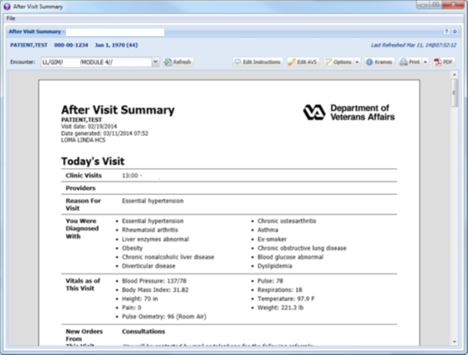

Test Patient, Module 4

PATIENT, TEST

Figure – AVS Interface

**IF**

You wish to select a different visit, select the desired visit and date from the *Encounter* drop-down list beneath the visit date, as shown in Figure 3. Click the **Refresh** button after selecting the visit.

**LL/GIM/TEST/MODULE 4//**

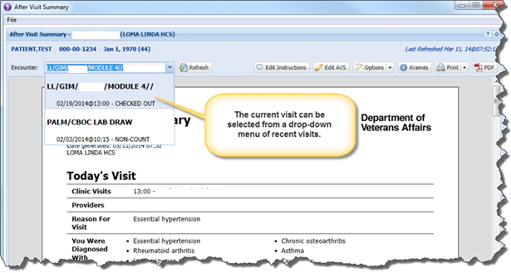

Figure – AVS Visit Selection

### AVS Sections

The following discussions introduce you to each section of the AVS document.

#### Header

The header, shown in Figure 4, appears at the top of the AVS document and displays the patient name, visit date, date the AVS was generated, and the facility name. The format and content of the header may be customized for a facility in the administration interface.

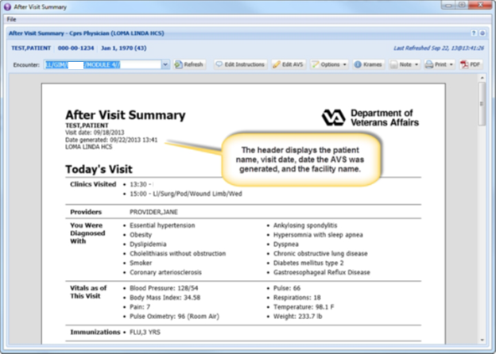

Figure – AVS Header

#### Visit Info, Diagnoses, Vitals, Immunizations

Figure 5 indicates the sections that contain the visit and provider information, the patient's diagnoses, vital signs, and immunizations.

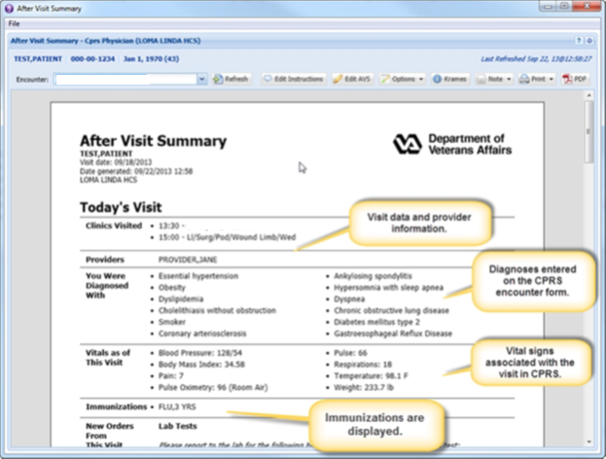

Figure – AVS Visit Information

#### New Orders

Figure 6 shows the New Orders section of the AVS. The orders section is categorized by type of order, including Consultations, Imaging, Lab Tests, Medications, and Text Orders.

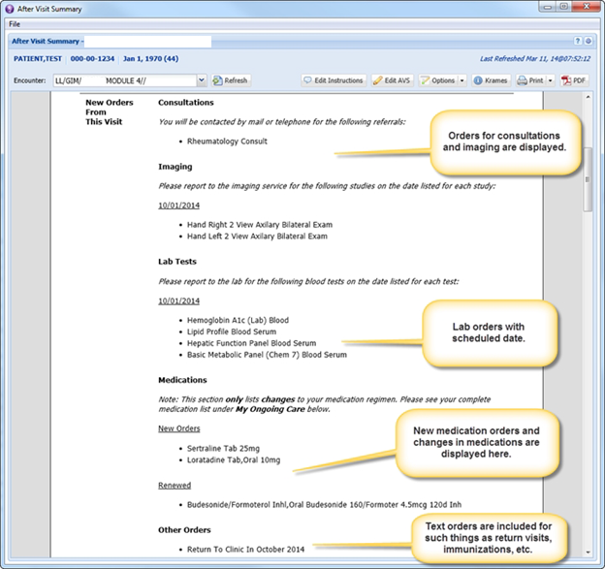

**Patient Test**

Figure – AVS New Orders

#### Appointments

Figure 7 shows the upcoming appointments within the next three months. This time period is configurable by facility.

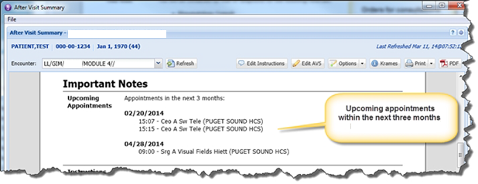

**LL/GIM/TEST/MODULE 4//**

Figure – AVS Appointments

#### Instructions

Figure 8 shows the free-text instructions that you may enter for display on the AVS.

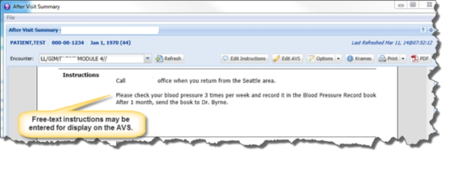

Figure – AVS Instructions

#### Primary Care Team

Figure 9 shows the patient's Primary Care Provider (PCP) and the Primary Care Team members.

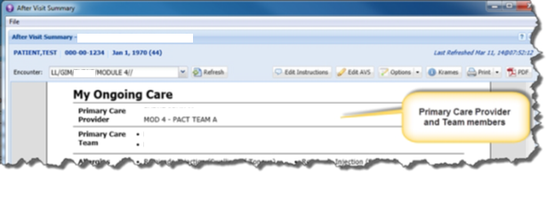

Figure – AVS Patient’s Primary Care Team

**Patient Test**

#### Allergies and Local VA Meds

Figure 10 shows the patient's allergies and adverse reactions, and the patient's current list of local VA medications.

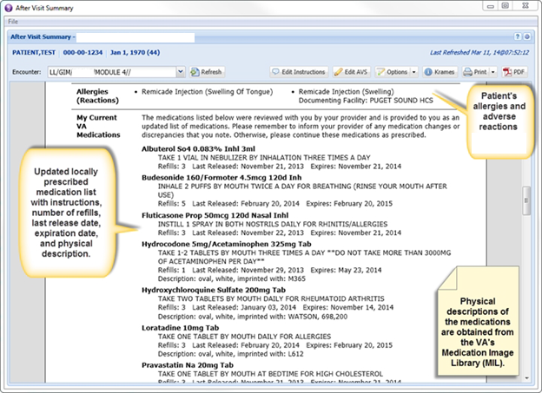

**LL/GIM/TEST/MODULE 4//**

Figure – Allergies and Local VA Meds

#### Non-VA Medications

Non-VA medications are pulled from the VistA databases for display, as shown in Figure 11.

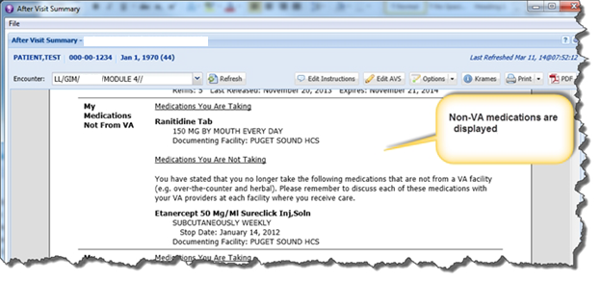

Figure – Non-VA Medications

#### Lab Results

Lab results may optionally be included in the AVS. By default, lab results are not included and must be selected from the Options menu. The user may choose to import lab results from the previous week, month, or from the last three months. Figure 12 shows the menu option for choosing a timeframe of lab results, and Figure 13 shows the lab results sorted by date.

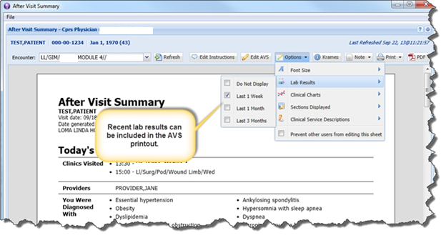

Figure – Lab Results

13:30 – Test Patient, Module 4

15:00 – Ll/Surg/Pod/Wound Limb/Wed

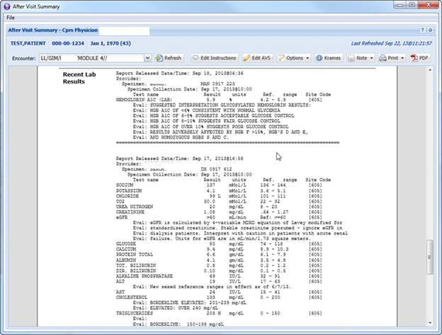

Figure – Recent Lab Results Sorted by Date

#### Clinical Charts

Clinical charts may be optionally included in the AVS, as shown in Figure 14. The charts are all line graphs and reflect the lab data and vital signs over the past year for the patient. Clinical charts that are available include BMI, BP, Cholesterol, Creatinine, eGFR, HbA1C, HDL, HGB, LDL, Platelets, Pulse, Triglycerides, and Weight.

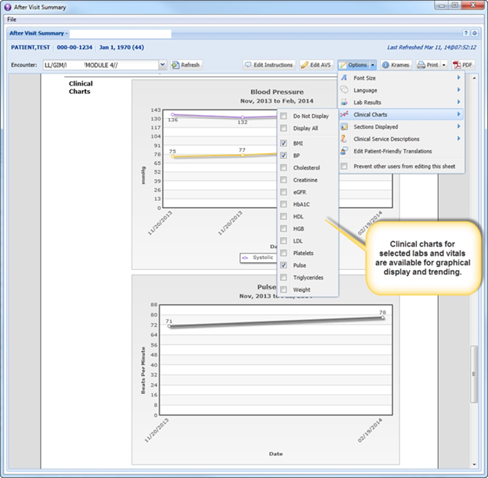

Figure – Clinical Charts

#### Footer

Figure 15 shows the footer section, which can be customized for the facility. The footer contents, along with the header and facility, clinic, and provider disclaimers, may be customized in the administration interface.

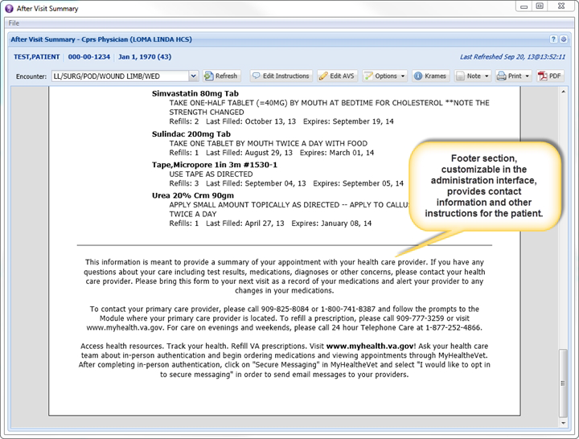

Figure – AVS Footer Section

#### Toggling Sections

Figure 16 shows the sections that appear on the AVS can be toggled on or off by selecting the sections to display from the drop-down menu.

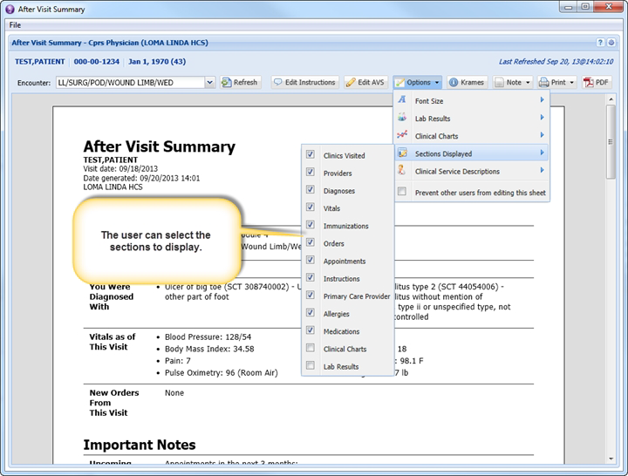

Figure – Toggling Sections

### AVS Functionality

The details of the functionality of the AVS is described in the topics that comprise this section.

#### Patient Instructions

Free-text patient instructions may be entered into the AVS, as shown in Figure 17. Rich text options are supported, including font style, size, color, and formatting. Images may be inserted into the text (e.g. from Krames-on-Demand), and bulleted and sorted lists may also be inserted into the text. Figure 18 shows the custom text that the provider may enter in the **Patient Instructions** section.

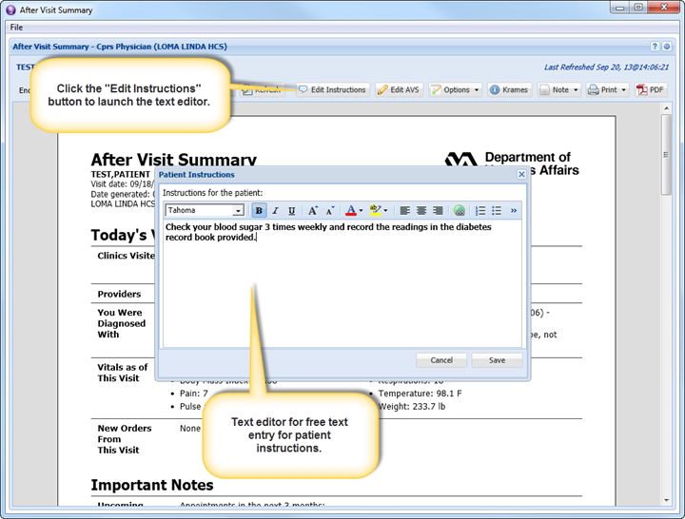

Figure – Patient Instructions

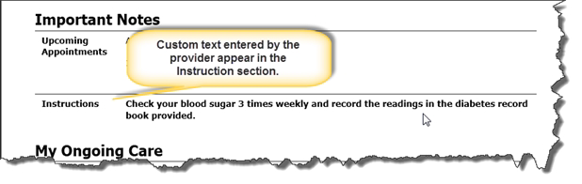

Figure – Custom Provider Text

#### Edit AVS

You can add/modify/delete any of the content in the AVS in a pop-up editor. A warning screen appears to remind you that manually refreshing the AVS will overwrite any custom edits, and auto refresh is turned off for the patient encounter if you make any edits, as shown in Figure 19 and Figure 20.

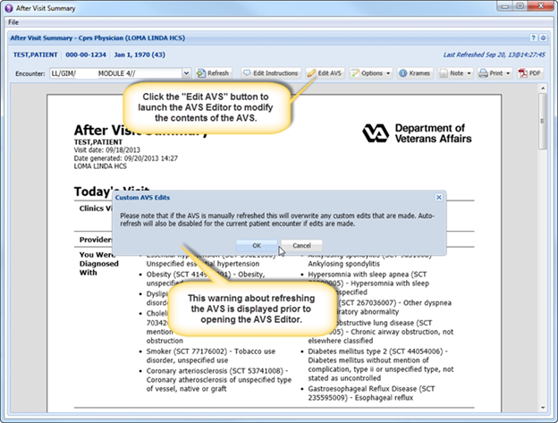

Figure – Edit AVS

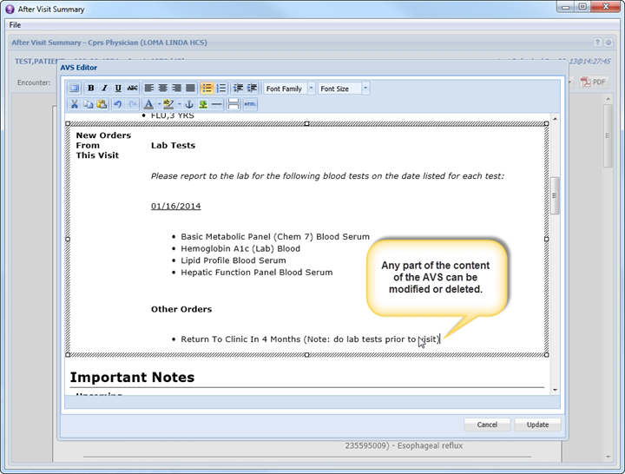

Figure – New Orders from This Visit

#### Font Size

For visually-impaired patients, the font size of the AVS may be adjusted, as shown in Figure 21. AVS supports large and very large font sizes in addition to the normal-sized text that is displayed by default.

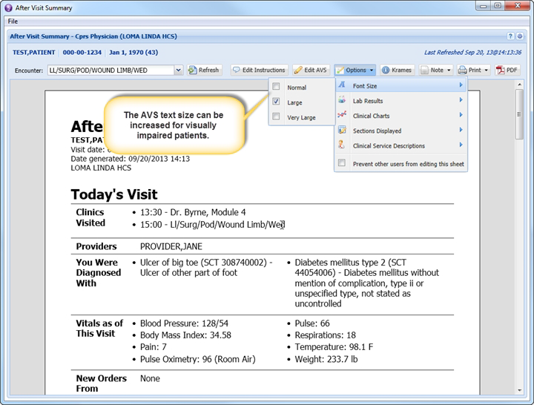

13:30 – Test Patient, Module 4

15:00 – Ll/Surg/Pod/Wound Limb/Wed

Figure – AVS Font Size

#### Clinical Services Information

Clinical Services information, including the name, location, phone, hours of operation, and comments, may be printed out along with the AVS document to provide the patient with helpful information regarding clinical services that he/she may visit during an upcoming appointment. You can toggle the inclusion of clinical services information from the Options menu, as shown in Figure 22 and Figure 23. All clinical services may be printed out, as shown in Figure 24 or you may choose selected services from the list.

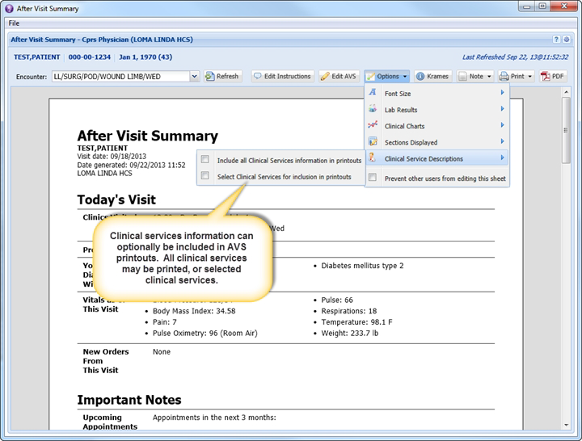

Figure – Clinical Service Information Menu Option

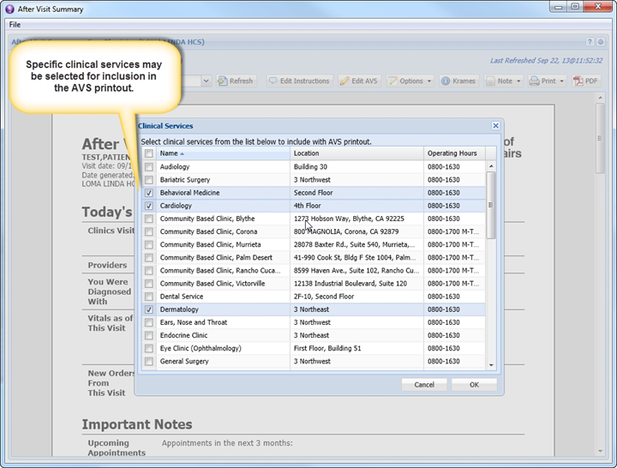

Figure – Choosing Clinical Services

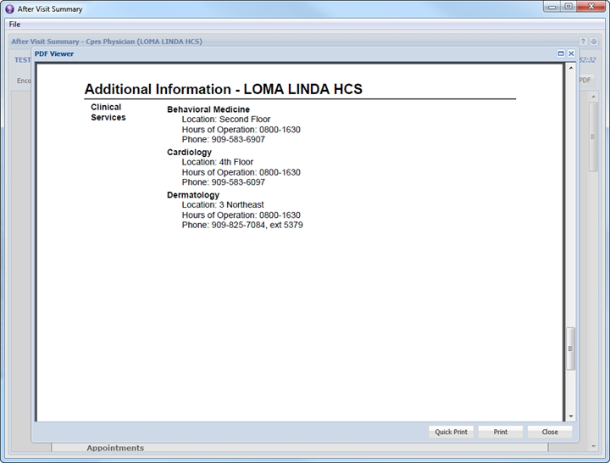

Figure – Clinical Services Sample Printout

#### Krames-On-Demand

Select the "Krames" button from the AVS toolbar to open Krames-on-Demand patient education material, as shown in Figure 25.

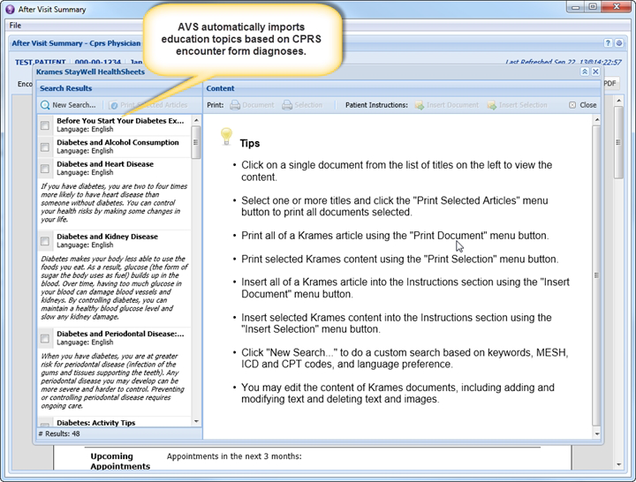

Figure – Krames-On-Demand Patient Education Material

When it is first opened for a patient, the Krames interface will automatically search the Krames database for patient education content based upon the patient's diagnoses from the encounter form. The user may also perform a manual search that supports queries for Krames content based on keywords, MESH codes, ICD-9 codes, and CPT codes. The patient's preferred language may also be selected on the search form.

The user can select multiple documents from the Search Results displayed on the left side of the screen, as shown in Figure 26, and choose to import them all into the Patient Instructions section of the AVS or printed off as separate documents.

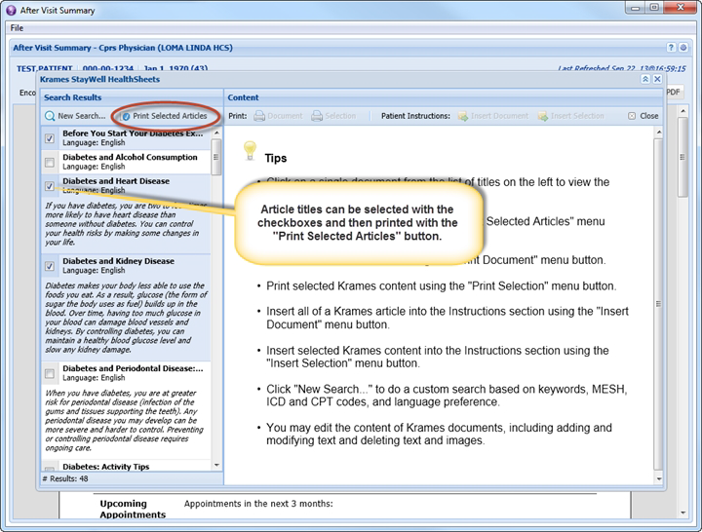

Figure – Krames on Demand Patient Search Results

Parts of a Krames article may be selected and inserted into the AVS or printed separately, as shown in Figure 27.

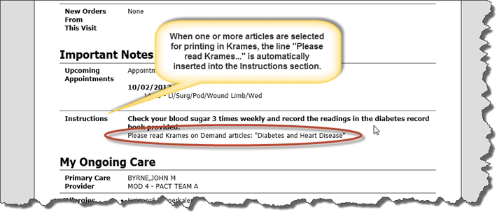

PHYSICIAN, TEST

MOD 4 – PACT TEAM A

Figure – Instructions Section Auto Population

Figure 28 shows a sample Krames-on-Demand Article that may either be read on screen, printed, or inserted in to the AVS Instructions section.

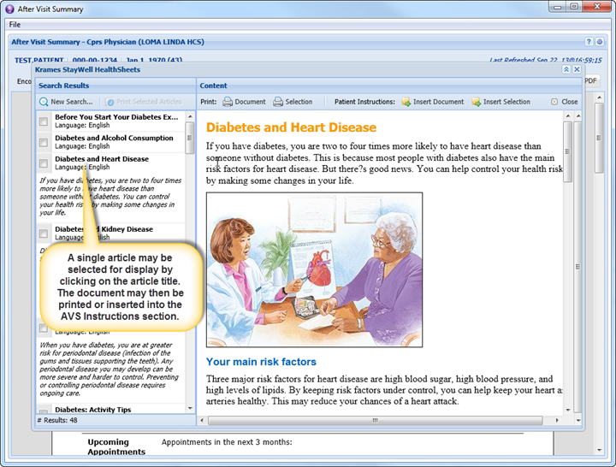

Figure – Sample Krames-on-Demand Article

Figure 29 shows you how to highlight and either print selections of a Krames-on-Demand article or insert the selected text into the AVS Instructions section.

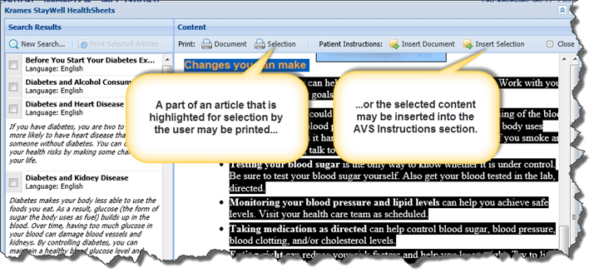

Figure – Printing or Inserting Highlighted Text

You may also search the entire Krames-On-Demand library by using the Search option, as shown in Figure 30

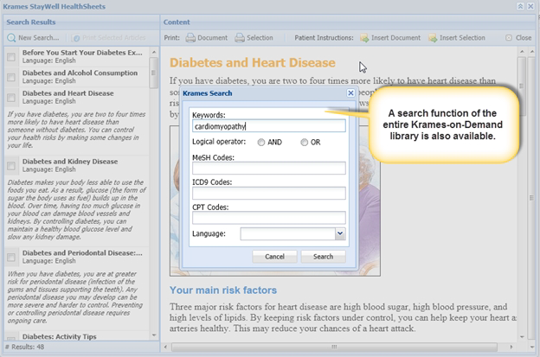

Figure – Krames-On-Demand Library Search Option

#### Printing

The AVS supports printing to a Windows printer that is connected directly to your workstation as well as to a network printer.

Clicking on the Default Printer option in the Print menu, as shown in Figure 31, will either print directly to the default Windows printer, or to a network printer ("VistA Printer") that has been selected as the default printer in AVS.

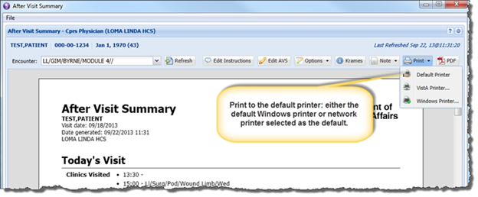

Figure – Choosing a Default Printer for the AVS Report

Clicking on the VistA Printer option brings up a dialog, as shown in Figure 32, which allows you to select from and search a list of network printers that is obtained from VistA.

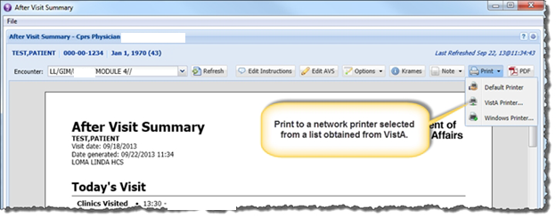

Figure – Choosing a VistA Printer for the AVS Report

You may select a printer from this list as the default printer that AVS will automatically print to when you select the Default Printer menu option. See Figure 33 for a sample list of VistA printers.

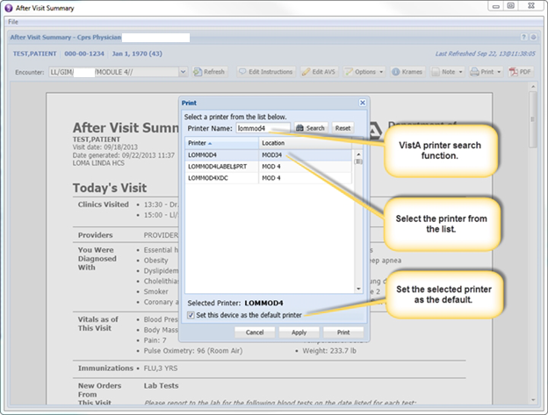

Figure – List of VistA Printers

Click on the Windows Printer option, as shown in Figure 34 to invoke the standard Windows print dialog (Figure 35) that allows you to print to the default Windows printer or to select from a list of printers installed on the your workstation.

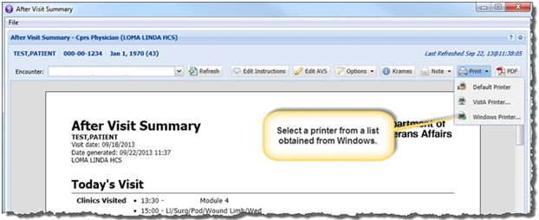

Figure – Choosing a Windows Printer Option

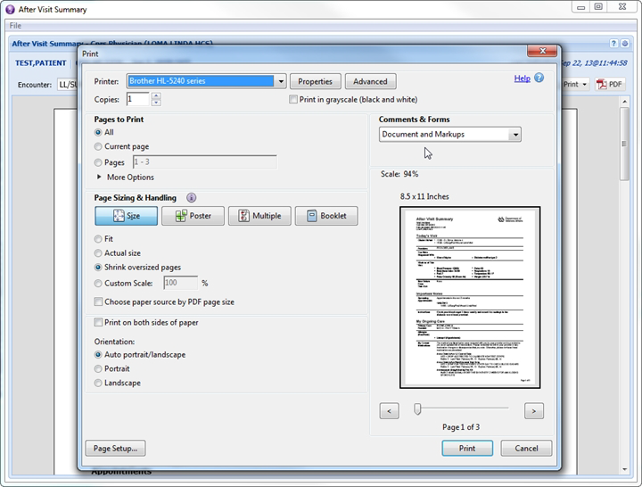

Figure – Print Option

#### Stub Note and VistA Imaging

AVS can upload a PDF copy of a patient's AVS to VistA Imaging to be a part of the patient's permanent medical record. This feature works in conjunction with the note creation functionality. A stub note is created which is linked to the document that is saved in VistA Imaging. The VistA Imaging upload occurs automatically in response to the AVS being printed for the first time. Figure 36 shows a sample stub note indicating that the patient has been provided with an AVS.

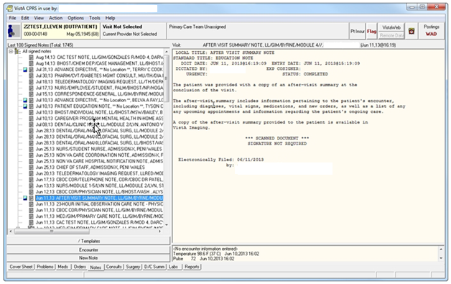

Figure – VistA Imaging Sample Stub Note

Figure *37* shows the resulting AVS that can be printed.

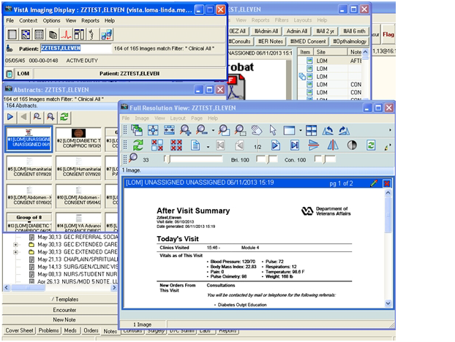

Figure 37 – AVS Associated with Stub Note PDF

You can generate and display a PDF copy of the AVS document within the AVS interface. Click the **PDF** button shown in Figure 38 to create the PDF version of the AVS.

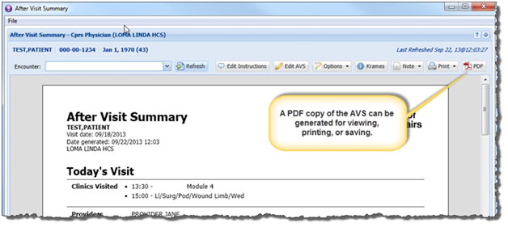

Figure –AVS PDF Option

The AVS opens up in a PDF viewer screen. Use the **File** option to print or save the PDF, as shown in Figure 39.

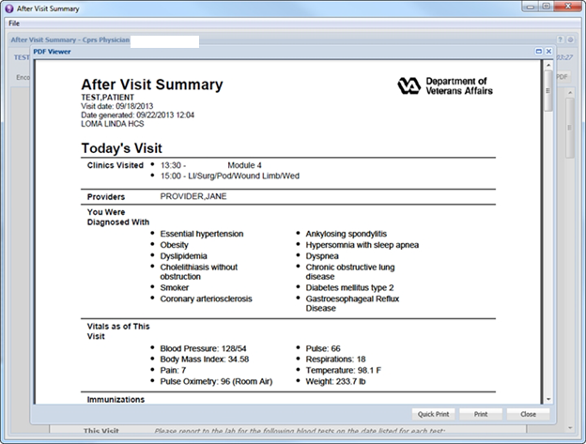

Figure – AVS PDF Viewer

#### Admin Settings

You can use the AVS Admin Settings interface to customize the AVS by facility. Options are:

* List clinical service locations and contact information
* Translate medical terms/orders into patient-friendly text
* Add disclaimers
* Add header/footer information

Use the Admin Settings interface to edit the list of clinical services, shown in Figure 40, which you can print out with a patient's AVS.

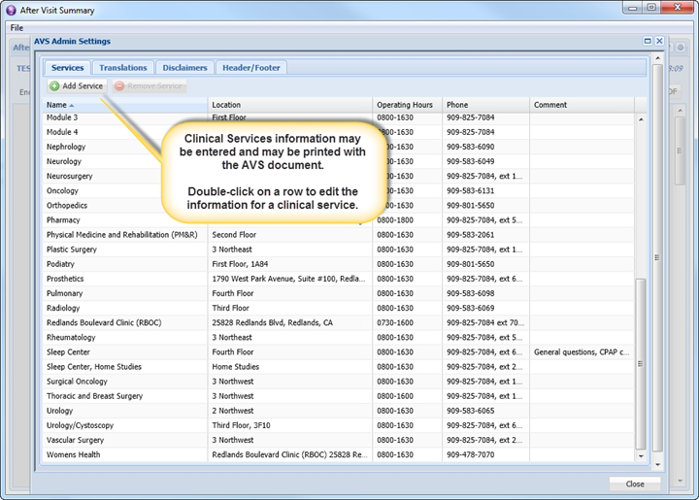

Figure – AVS Admin Settings Edit Mode

You can also use the admin interface to provide patient-friendly translations for various pieces of text, such as orders and locations that appear in the AVS. Figure 41 shows a sample patient-friendly text translation for “RTC 3 months”.

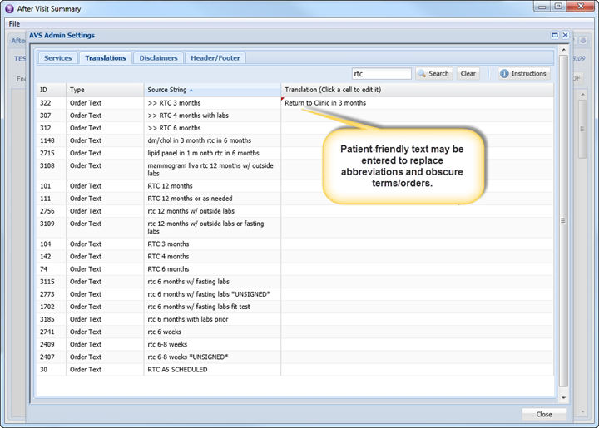

Figure – Patient-Friendly Text Translation

You can add custom disclaimers for different users, clinics, and for the facility, as shown in Figure 42.

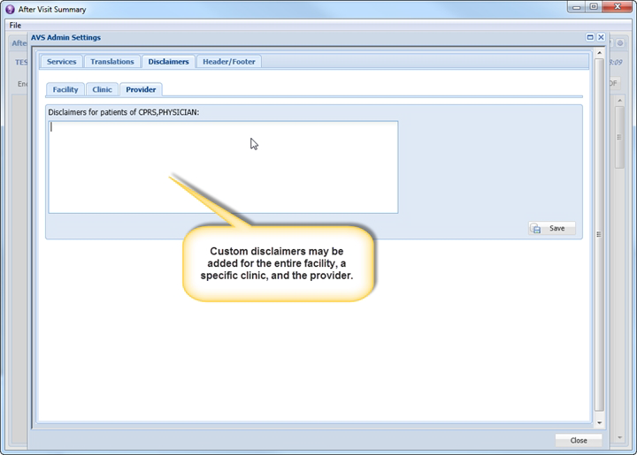

Figure – AVS Custom Disclaimer

You can also configure the header and footer boilerplates of the AVS for the facility, as shown in   
Figure 43.

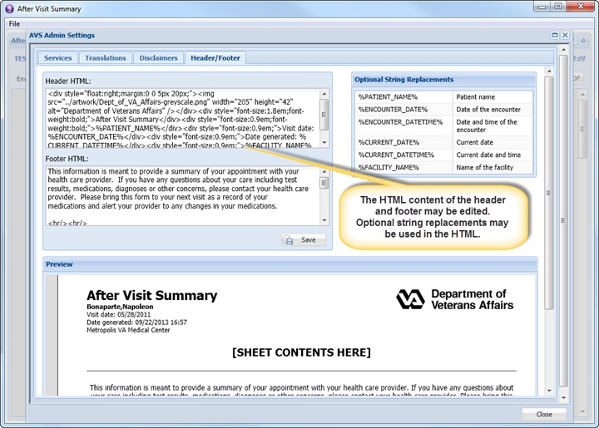

Figure – AVS Header / Footer Edit Mode

## Changing User ID and Password

This information will be available in the next version of this document.

## Exit System

This information will be available in the next version of this document.

## Special Instructions for Error Correction

Describe all recovery and error correction procedures, including error conditions that may be generated and corrective actions that may need to be taken.

## Caveats and Exceptions

If there are special actions the user must take to insure that data is properly saved or that some other function executes properly, describe those actions here. Include screen captures and descriptive narratives, if applicable.

# Project-Specific Scenario

The following is an example AVS document complete with lab results and charts.

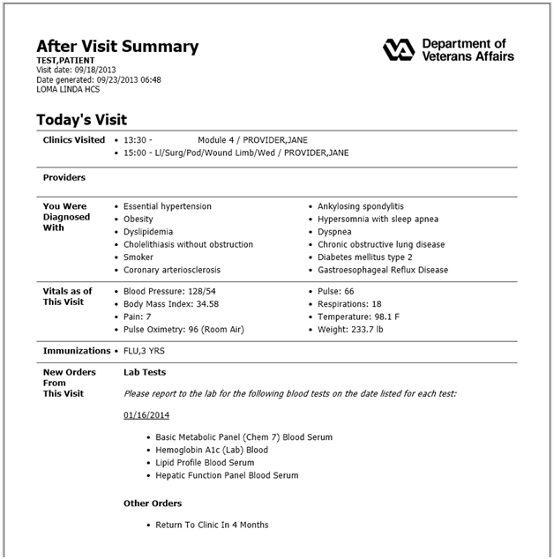

**NURSE, TEST**

**PHYSICIAN, TEST**

Figure – Sample AVS, with Lab Tests

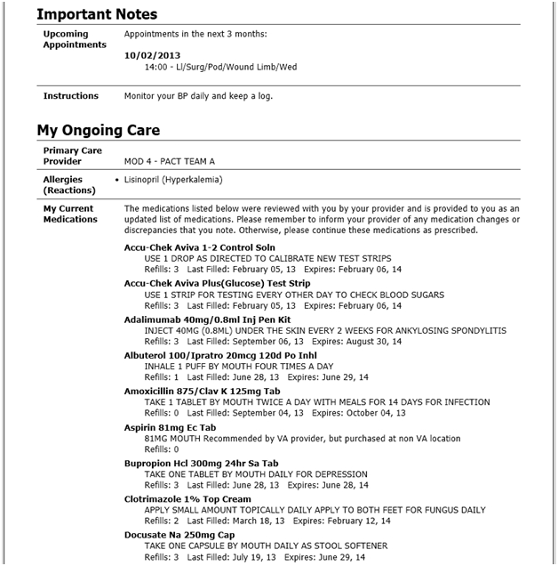

Figure 45 – Sample AVS, Appointments, Current Medications

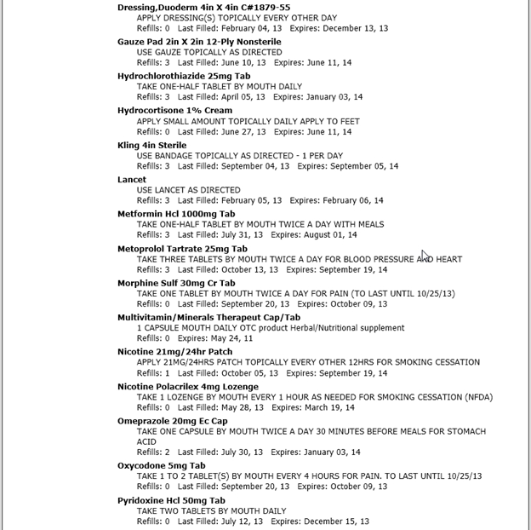

Figure 46 – Sample AVS, Current Medications, Continued

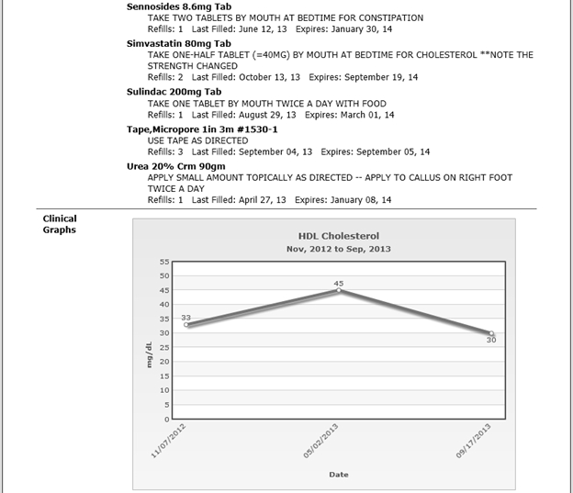

Figure 47 – Sample AVS, Clinical Graphs

Sample AVS, Clinical Graphs, Continued

Figure 48 – Sample AVS, Clinical Graphs, Continued

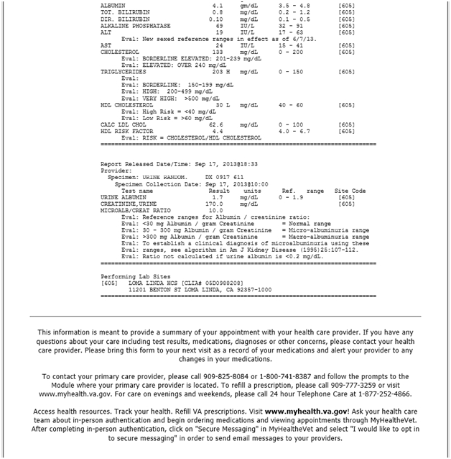

Figure 49 – Sample AVS, Recent Lab Results



Figure - Sample AVS, Recent Lab Results Continued

# Troubleshooting

You can access AVS online help by clicking the help button, or question mark icon located in the upper-right corner of the AVS screen. A separate browser window opens up and displays the help contents.